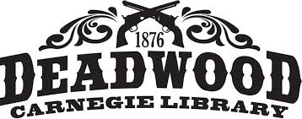

Deadwood Public Library
Library Board of Trustees
Proposed Agenda
Thursday April 14, 2022
8:30 am

- Call to Order

- Additions or revisions to the agenda

- Approval of meeting minutes March 17, 2022

- Approval of Bills

- Correspondence and Communication

- Staff Reports
- Director’s report

- Unfinished Business
- Chamber Mixer

- New Business
- Board meeting schedule
- Staffing
- Movie Night at Outlaw Square

- Comments

- Adjournment

