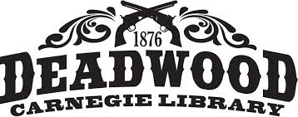

Deadwood Public Library
Library Board of Trustees
Proposed Agenda
Thursday march 17, 2022
8:30 am

- Call to Order

- Additions or revisions to the agenda

- Approval of meeting minutes February 10, 2022

- Approval of Bills

- Correspondence and Communication

- Staff Reports
- Director’s report

- Unfinished Business
- Library hours beginning April 4
- Review and approval of Registration policy
- Chamber Mixer

- New Business
- Approval of Annual Report
- Approval to attend the BH Librarians mini conference
- Review of library technology plan
- National Library Week, April 3-9

- Comments

- Adjournment

Next meeting Thursday, April 14, 2022

